Client-Server Model
- In order to create web sites and web application, it IS important to understand how web applications and the internet work
- Internet: Refer to a network of computers all over the world, or network of networks. The primary structure of these networks is the client-server network.
- This network permits the world to connect our own individual machines to countless machines that make up the networks of the internet

Client-Server
- Client-server model is referred to a design of network machines with the main files, programs and services on a single computer called a server
- These resources can be distributed to other machines called clients
- The internet is an example of a client-server architecture, since multiple resources(files, programs, services, etc) are stored on servers
- The internet is a huge, complex map of clients and servers, all connected together, allowing the world to share an infinite supply of electronic resources.
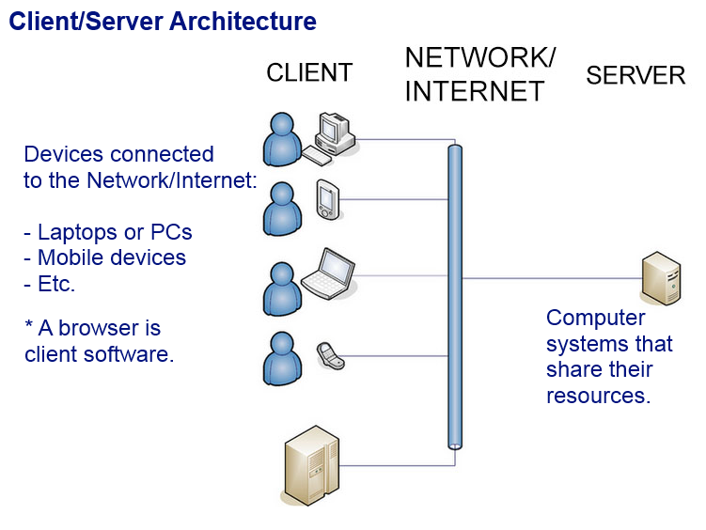
EXAMPLE OF THE INTERNET

- A server is also the software that manages the server’s connections and access
It also serves up requests for resources that are made by client machines.
- The machine that the server software that lives in can be any computer that is powerful enough to run the server and perform the tasks the server needs to perform
- Different types of servers include:
- Web servers that host web sites
- Database servers that host database full fo data
- File servers that host games user can connect to and play with each other
- A print server that hosts printing services which manage print jobs and a network of printers
- A client refers to a machine or an application
- Currently, a computer is connected to a local network and there it is a client machine
- Any software program that allows the lenient machine to request information from a server, receives the returned results and then presents those results in a human-readable form. This is referred to a client-software
- A web browser(chrome, safari, bing, etc) is a client since it used to request web pages, which are then supplied in the browser window to see or interact with.
- When running an email program such as Outlook or Thunderbird, an email client is used
- An FTP client is a piece of software(such as WS-FTP, Core FTP, AnyClient, FileZIlla, etc) that allows a server to connect in order to upload or download files

Web Applications
- Some of the technologies used to develop applications are server-side technologies, and others are client-side technologies.
- Server-side technologies, such as PHP, Pearl, and MySQL perform their processing on the server
- Client-side technologies, such as HTML, CSS, and JavaScript perform their processing on the client
-JavaScript is a client-side technology by using technologies such as Node.js
- PHP is a server-side scripting language that process data sent to the server from the client and provides file/database access
-MySQL is a database server software that hosts large amounts of data that can be manipulated and accessed via SQL and other server technologies
- JavaScript is primarily a client-side scripting language, however it is now possible to use Server-Side JavaScript(SSJS).
- Multiple JavaScript engines(virtual machines that can interpret/execute JavaScript code) such as V8(written in C++), SpiderMonkey(written in C), and Rhino(written in Java) can make it possible to run various special JavaScript run-time environments and frameworks such as Jaxer and Node.js
- The data flow in a client-server network can be complex for interactive web pages and for web applications. However, by creating static web pages(web pages without interactivity) it will be easier to obtain a simple data flow on a web server.
- Web pages contain contents that do not change unless the programmer changes it and uploads a new version.
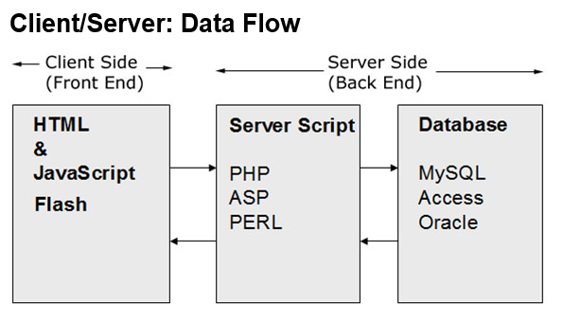
Example of Client-Server Data Flow

The Request/response Model
- The Request/Response model is how clients and servers communicate with each other. The client sends requests to the server, while the server then processes and obtains these requests, and then sends the response back to the client.
- The process goes as follows:
- Click the link/bookmark/ or type the URL into the browser
- An HTTP Request object is created
- The browser sends the request object to the link
- The Request arrives at the server and is processed.
- A Response object is created. It contains the destination address and the string of the data which contains the request file. A response code of 200 and the message “OK” signifies that the request was successful. 403 means the resource is forbidden and can not b e viewed, 404 means the resource can not be found, 408 means the request is timeout, and 500 means internal server error
- The server sends the response back to the machine that made the request
- The browser receives the Response object, opens it, and parses the string of data
- It builds the HTML document out of the received data
- If there are any references to files in the data, such as an image or a CSS file, new requests are made and sent to the server for each one of those assets
- For instance, the file has a couple of images, and it also references a javascript file and a css file. New requests are made for each of those assets
- After the HTML document is created, the browser parses the responses from any other asset request: CSS files are loaded and added to the HTML images are added, etc
- The browser renders the complete HTML document so that its visible to the user

